Modern Slavery and Human Trafficking Statement
For the Financial Year Ended April 2022
This statement is made in accordance with Section 54, Part 6 of the
Modern Slavery Act 2015. It constitutes our modern slavery and human
trafficking statement for the financial year ended April 2022

Structure
The Fresh Olive Company T/a Belazu is a subsidiary of William Jackson Food Group a sixth-generation family business. We procure, manufacture and supply a wide range of Mediterranean and Middle-Eastern inspired food products to thousands of customers from retail supermarkets to casual dining chains, from independent restaurants to FMCG manufacturers.
We are based in Greenford, Middlesex where both our factory and warehouse premises are located. We employ around 230 people and generate an annual turnover of c£37m.
We source over 600 different ingredients and packaging from c.150 suppliers from both the UK and overseas, together with c.350 suppliers for indirect goods and services.

Our Mission and Values
Our mission is to bring Flavour and Inspiration to every table, without compromise. Our cultural values underpin every aspect of our business, and consist of looking after our People, Customers, Honesty, Accountability and Passion.

Policy Statement
We manage our supply chain with a great degree of care, recognising our supply partners as a crucial part of our business. We have direct suppliers, from whom we buy ingredients and packaging, and indirect suppliers, such as those who supply our utilities. We are committed to eradicating all instances of modern slavery or human trafficking taking place in our business, or the suppliers we deal with. This statement reflects our commitment to acting ethically and with integrity in all our business relationships, and to implementing and enforcing effective systems and controls to ensure no slavery or human trafficking exists anywhere in our supply chains.
Ultimate responsibility for the prevention of modern slavery rests with the Company’s leadership. The Belazu Board has overall responsibility for ensuring this policy and its implementation comply with our legal, moral and ethical obligations. Leaders at all levels are responsible for ensuring those reporting to them understand and comply with this policy and are given adequate and regular training on it and the issue of modern slavery.

Training and Awareness
We are working with the Stronger Together programme to ensure all relevant colleagues receive the appropriate level of training to raise awareness of modern slavery and human trafficking, and the knowledge to address any related issues which may arise. We have conducted Stronger Together training for key members of People, Operations, Technical and Procurement functions and we have also added training to part of our induction process for all our colleagues. Some colleagues on development programmes are also being given the training.

We aim to encourage openness and will support anyone who raises genuine concerns in good faith under this policy, even if they turn out to be mistaken. We are committed to ensuring no one suffers any detrimental treatment as a result of reporting in good faith their suspicion that modern slavery of whatever form is or may be taking place in any part of our own business or in any of our supply chains. Through our training programme and procedures, colleagues have been reminded of the Group Whistle-blowing Policy as the primary method of reporting any suspicions or evidence of slavery or human trafficking. We have also re-publicised the Belazu and WJFG whistle-blowing policies in our internal comms to ensure that all of our people understand how to safely raise any concerns they may have about possible instances of modern slavery or human trafficking within our own operations or our supply chains.

We accept and take seriously concerns communicated anonymously. The Company encourages members of the public or people not employed by us to write, in confidence, to the Company Secretary or the Group People Director to raise any concern, issue or suspicion of modern slavery in any part of our business or related supply chain.

Prevention Within Our Business and Supply Chain

We will take action to address any evidence of slavery or human trafficking. During the past year we have undertaken the following key activities in order to assess and manage such risks within our business and supply chain:
- Co-ordinated activities across the Group (listed below)
  - Approved the implementation of a supplier management software to be rolled out across the group in FY23 to enable better transparency and management of risk of our supply chain and its suppliers
  - Given a summary of Modern Slavery warning signs and policies via our in-house Journal
  - Conducted GLAA-compliant audits on all labour providers
  - Become a member of Food Network for Ethical Trade (FNET)
- We continue to carry out random data checks at regular intervals, looking for things like multiple colleagues living at the same address and colleagues with the same bank accounts.
- Distributed Stronger Together materials for display at all our sites and in multiple languages.
- Review and update risk analysis of our direct suppliers
- Engage with our suppliers both to convey to them our stance on modern slavery and to gain an understanding of the measures taken by them to ensure modern slavery is not occurring in their businesses
- Continued to be active members of the Supplier Ethical Data Exchange (Sedex) and encouraged all of our suppliers to engage with organisations such as Sedex or the Ethical Trade Initiative (ETI) that promote the core conventions of the UN’s International Labour Organisation
- Record and report on Sedex (or equivalent) membership of our ingredients and packaging suppliers
- Sign-posted suppliers to resources provided by Stronger Together and Sedex

Our priorities for the coming year are:

- Develop targets against our ethical sourcing KPI’s in order to improve SEDEX equivalent engagement
- Extend our supplier risk assessments to selected categories of indirect expenditure
- Commence audits on our suppliers using a risk-based approach
- Extend risk assessments down the supply chain into ‘hot-spot’ areas
- Carry out supplier engagement training
- Re-publicise the Belazu and WJFG whistle-blowing policy
- Extend internal Stronger Together training to all colleagues
- We will ensure that GLAA-compliant audits are conducted on all labour providers

This statement has been reviewed and approved by the Board on 25 October 2022.
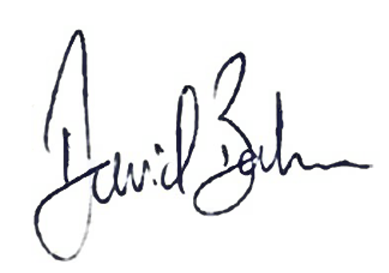
Signed
David Balmer
Managing Director

